Helpful Links:

* [What is Docker? | Docker Docs](https://docs.docker.com/get-started/docker-overview/)
* [How To Create And Deploy Docker Applications | by Education Ecosystem (LEDU) | Geek Culture | Medium](https://medium.com/geekculture/how-to-create-and-deploy-docker-applications-1b00e4246c1d)
* [How to Install Docker and Docker Compose on Linux (howtogeek.com)](https://www.howtogeek.com/devops/how-to-install-docker-and-docker-compose-on-linux/)

Deployment Steps:

**EC2/DOCKER CREATION**

**1. Create both an AWS and Docker account.**

You can create your Docker Account via email or Google Account or GitHub Account

[Create an account | Docker Docs](https://docs.docker.com/accounts/create-account/#:~:text=Create%20an%20account%20You%20can%20create%20a%20free,can%20access%20all%20Docker%20products%2C%20including%20Docker%20Hub.)

[Free Cloud Computing Services - AWS Free Tier (amazon.com)](https://aws.amazon.com/free/?trk=7d475c59-1af1-47f8-b4c7-88482cbd0e73&sc_channel=ps&s_kwcid=AL!4422!10!71880808791517!71881335348518&ef_id=a36486972a2c14d91a3ae06f0e292a9a:G:s&msclkid=a36486972a2c14d91a3ae06f0e292a9a&all-free-tier.sort-by=item.additionalFields.SortRank&all-free-tier.sort-order=asc&awsf.Free%20Tier%20Types=*all&awsf.Free%20Tier%20Categories=*all)

**2. Create five repositories on docker named 'bucstop' , 'gamemicroapi' , 'gamemicrosnake' , 'gamemicropong' , 'gamemicrotetris'**

Link on how to create your repo in Docker: [Create repositories | Docker Docs](https://docs.docker.com/docker-hub/repos/create/#:~:text=Create%20a%20repository%201%20Sign%20in%20to%20Docker,3%20Near%20the%20top-right%20corner%2C%20select%20Create%20Repository.)

**3. Create an ubuntu Ec2 on AWS.**

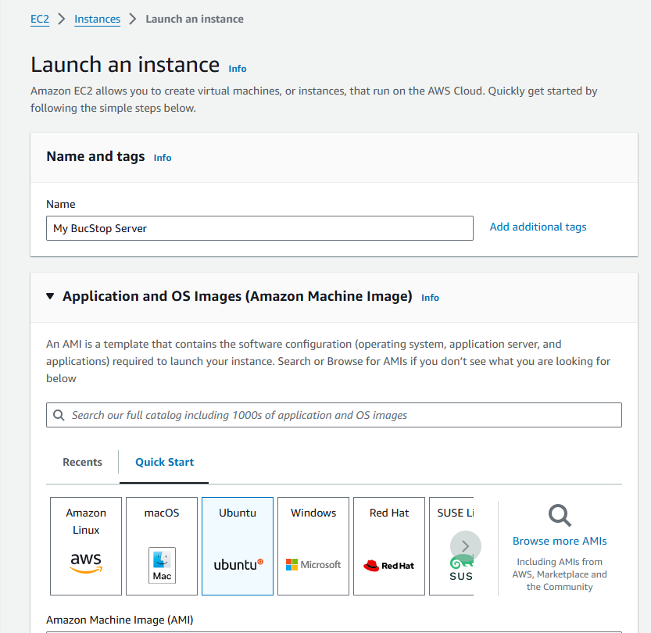

**Click Create new key pair to create a .pem key (can be named anything) make sure you save it in an accessible local directory**

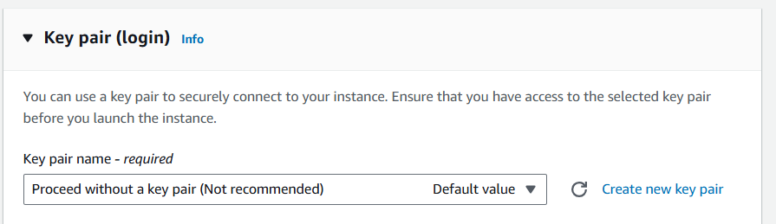

**Click 'allow HTTP traffic' go down and click Launch Instance.**

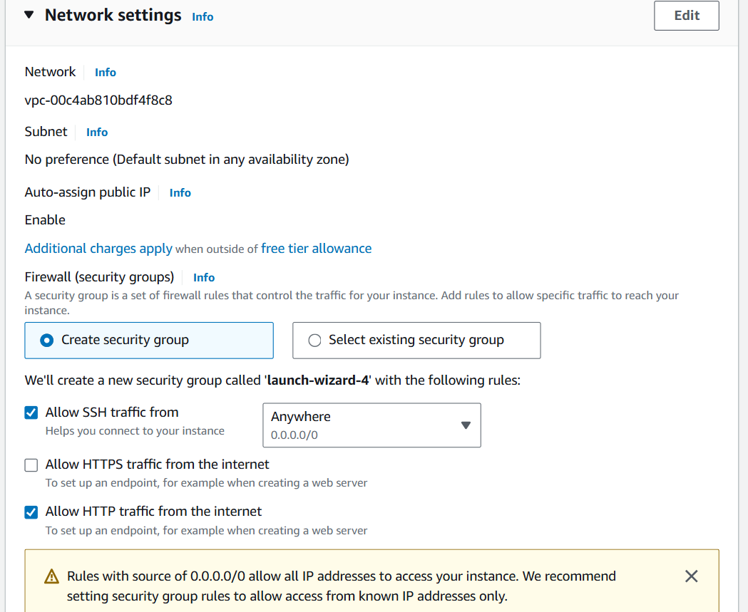

**4. Open your local directory wherever the .pem key is stored and run CMD.**

**5. Go back to the EC2 instance and click 'connect' and then click on the 'SSH' tab.**

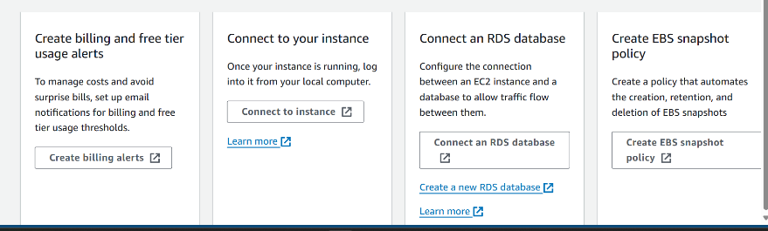

**6. This should provide you with a copy/paste text (**[**ubuntu@ec2-192.192.192.192**](mailto:ubuntu@ec2-192.192.192.192)**)**

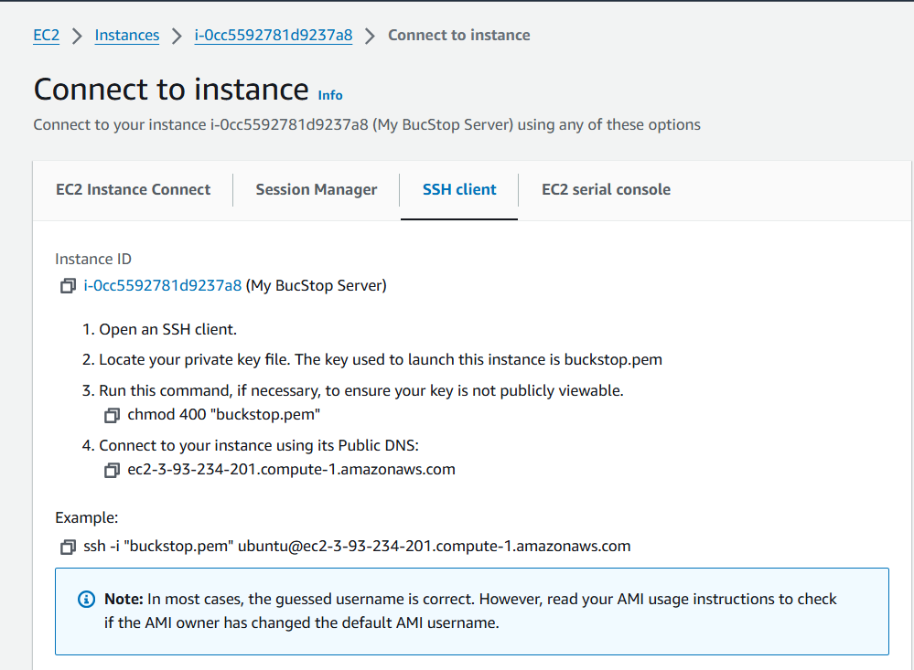

**7. Paste this along with the 'ssh -i .\'pemkeyname'.pem and you should be good. (May need to remove inherited permissions on pem key because windows** **is lame.**

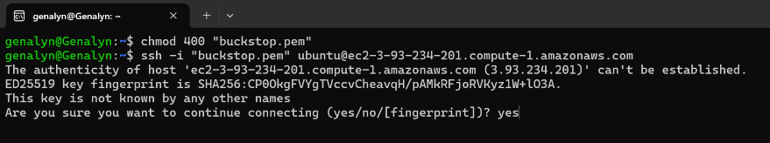

**Once your successful It should look like the image below.**

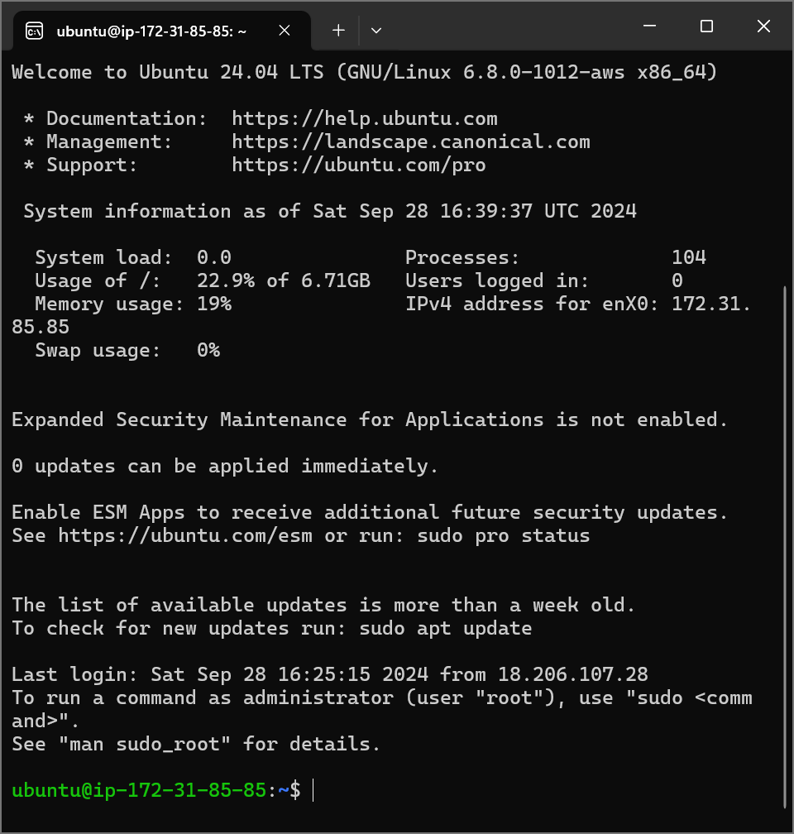4

**8. Once in, create an account using 'su adduser' and also grant them sudo privileges.**

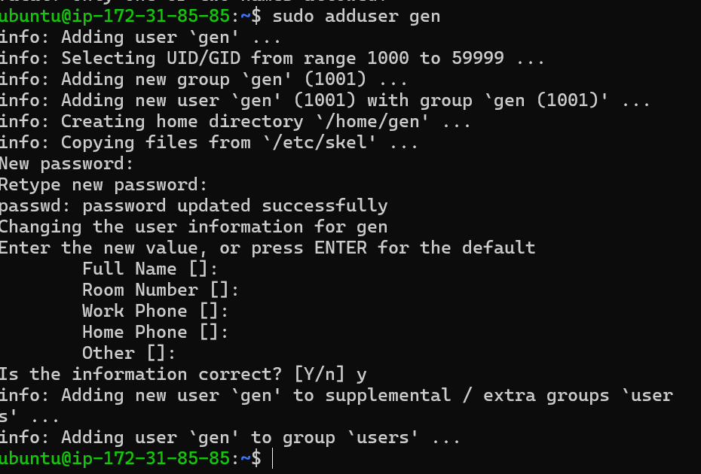



**9. Switch users to said account (make sure the new user has sudo privileges if not add this steps)**

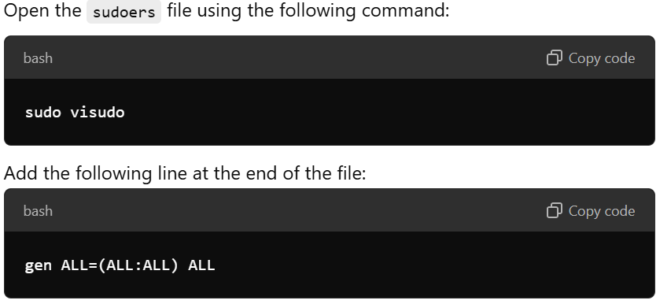

**Make sure to save the changes in the file before you exit. Nano: CTRL + X to exit and then Y to save and then Enter.**

**Create a folder called 'scripts' under 'home'.**





**10. CD into the scripts folder and add the script files from GitHub.**

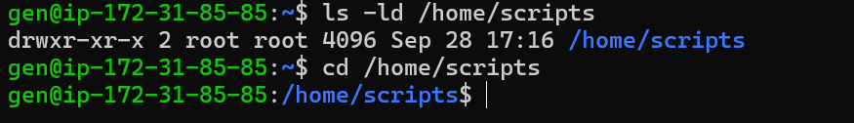

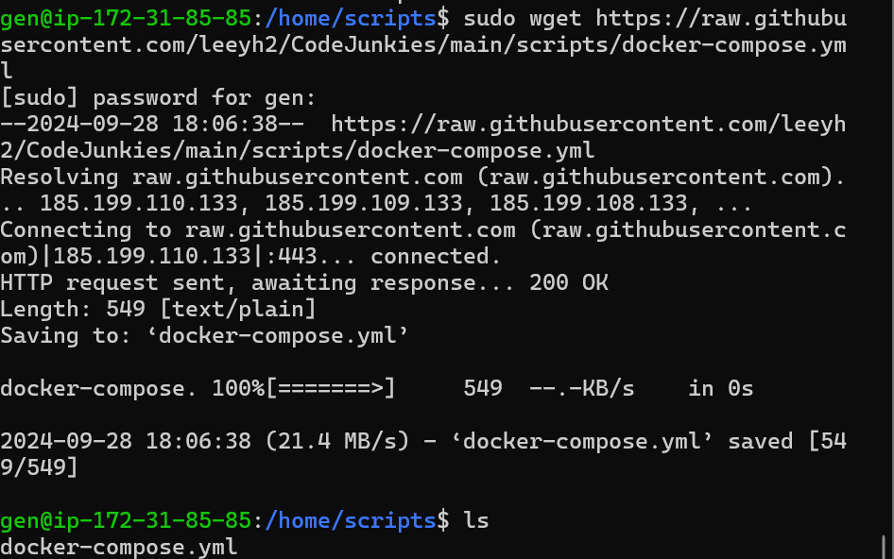

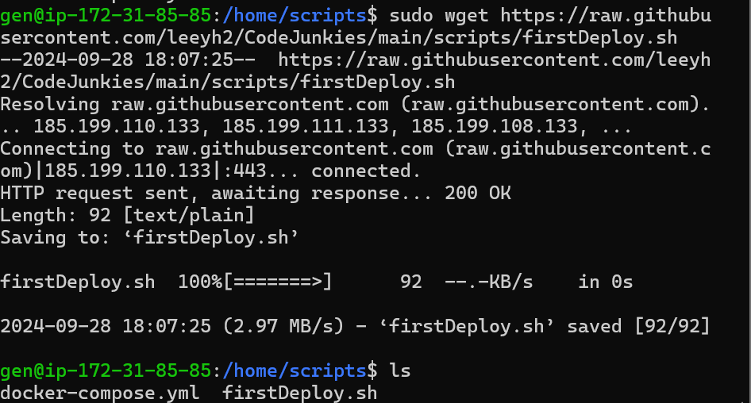

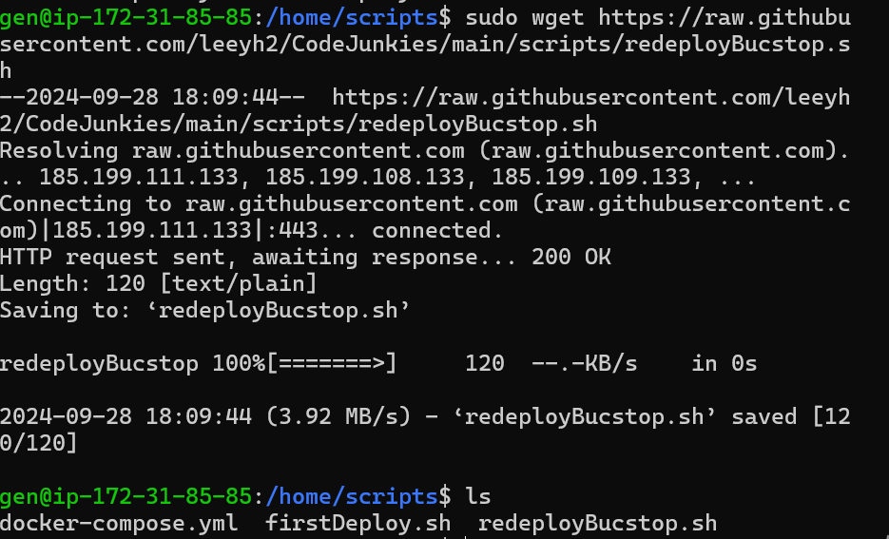

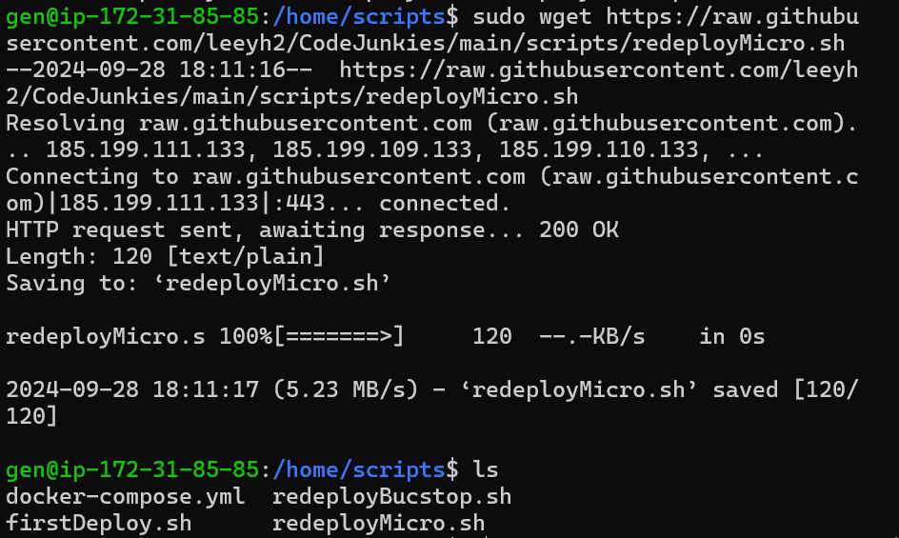

**11. Grant ./firstDeploy.sh permissions to execute (sudo chmod +x)**

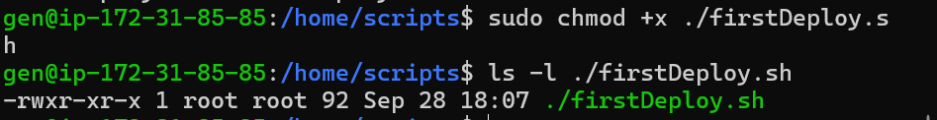

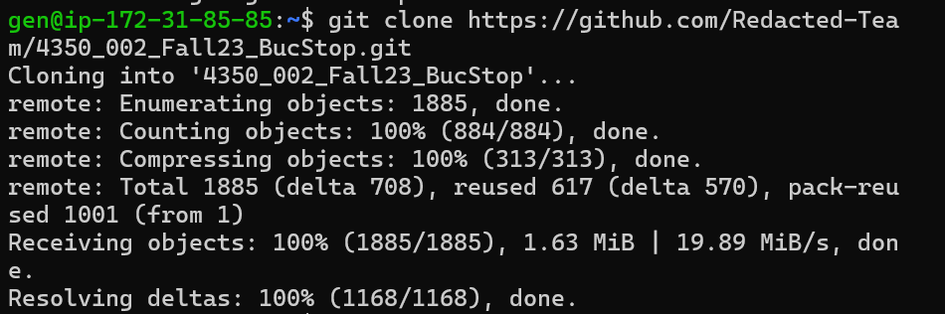

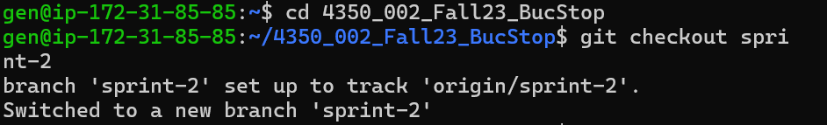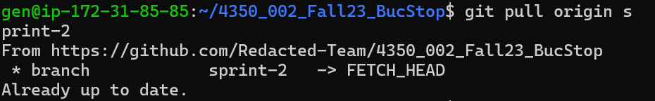

**Installing Docker in your EC2 instance**

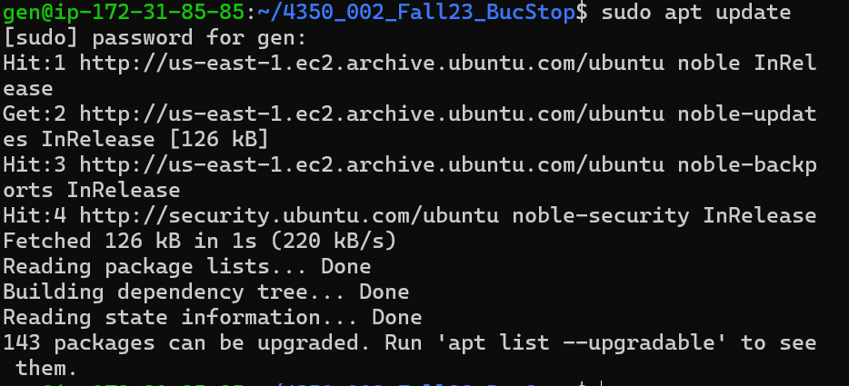

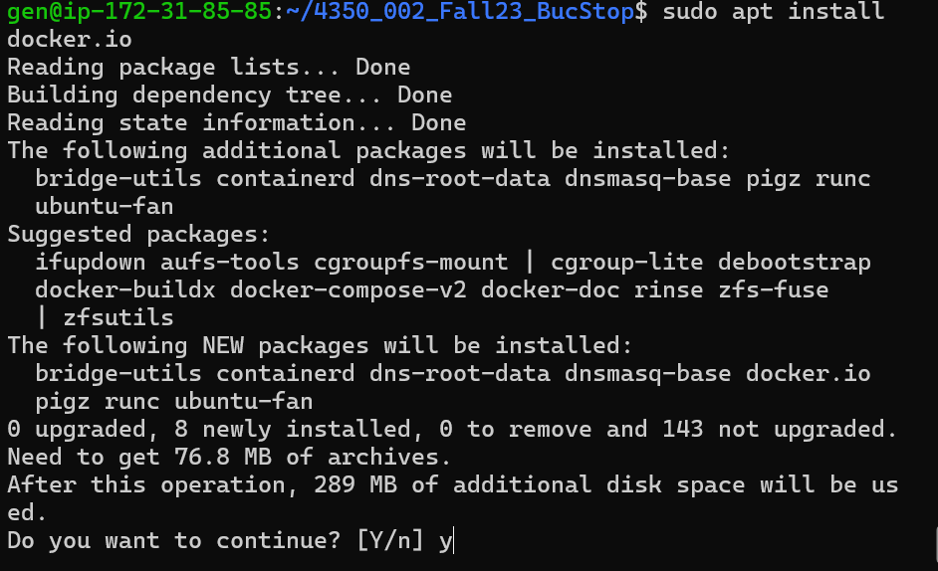

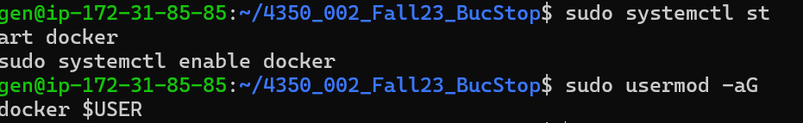

**Log out and log back in. Verify Docker installation**



**Clone the following Repositories**

* Links to the repositories:
  + <https://github.com/Redacted-Team/4350_002_Fall23_BucStop>
  + <https://github.com/Redacted-Team/4350_002_Fall23_APIGateway>
  + <https://github.com/Redacted-Team/4350_002_Fall23_Tetris>
  + <https://github.com/Redacted-Team/4350_002_Fall23_Snake>
  + <https://github.com/Redacted-Team/4350_002_Fall23_Pong>

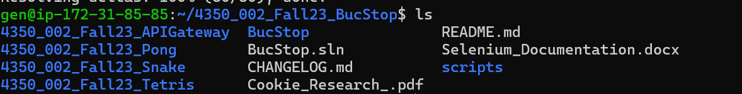

**Just a reminder on the GameMicroServer/Dockerfile for the games use the following: see below code snippets. FYI: you need to change the name sirethan you whatever is your name in your docker hub.**

* docker build -f Snake/Dockerfile -t sirethan/gamemicrosnake .
* docker build -f Tetris/Dockerfile -t sirethan/gamemicrotetris .
* docker build -f Pong/Dockerfile -t sirethan/gamemicropong .

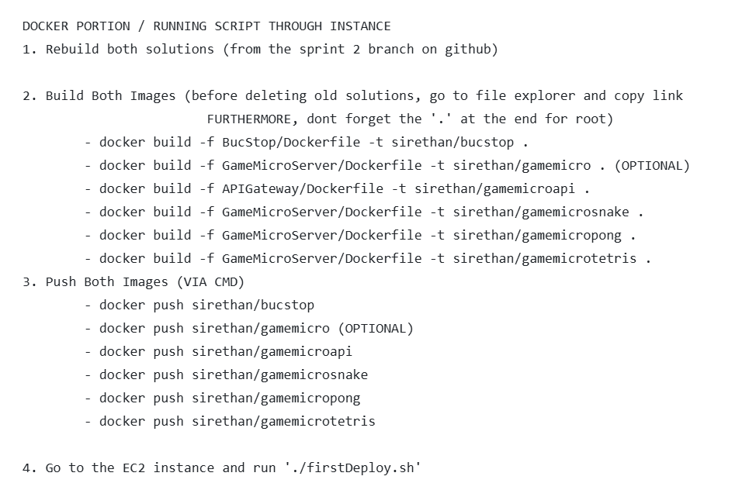



**Use your docker email or if you used your GitHub account use your username and the password you used. It will tell you when you successfully logged in.**



**Use your own username instead of sirethan to push images into your Docker repository.**

* docker push sirethan/bucstop
* docker push sirethan/gamemicroapi
* docker push sirethan/gamemicrotetris
* docker push sirethan/gamemicrosnake
* docker push sirethan/gamemicropong

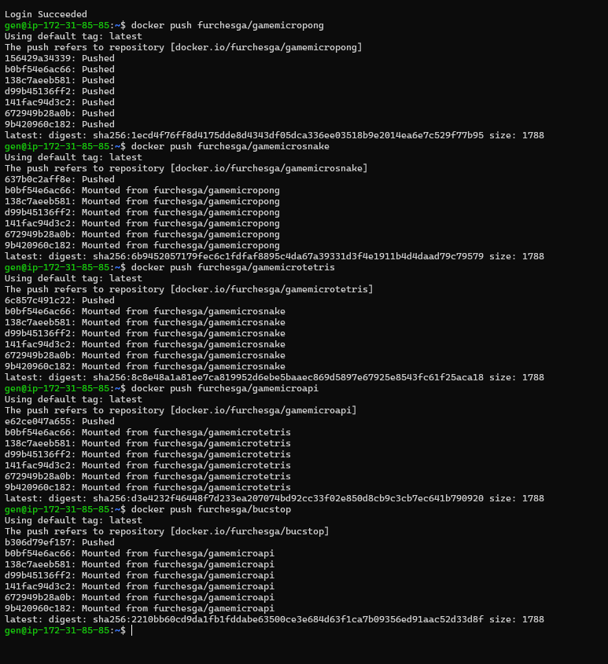

**How to install Docker and Docker Compose in Linux**

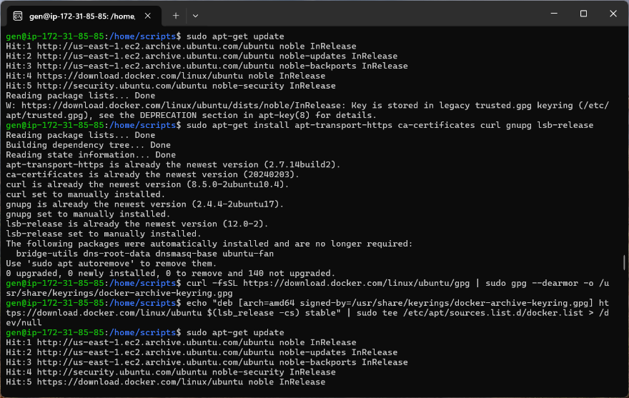5

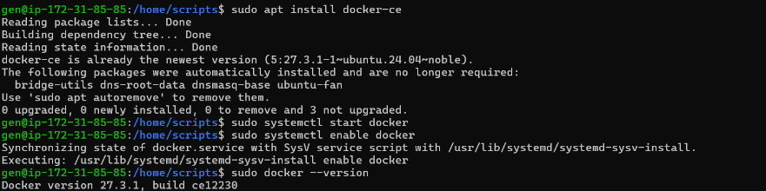

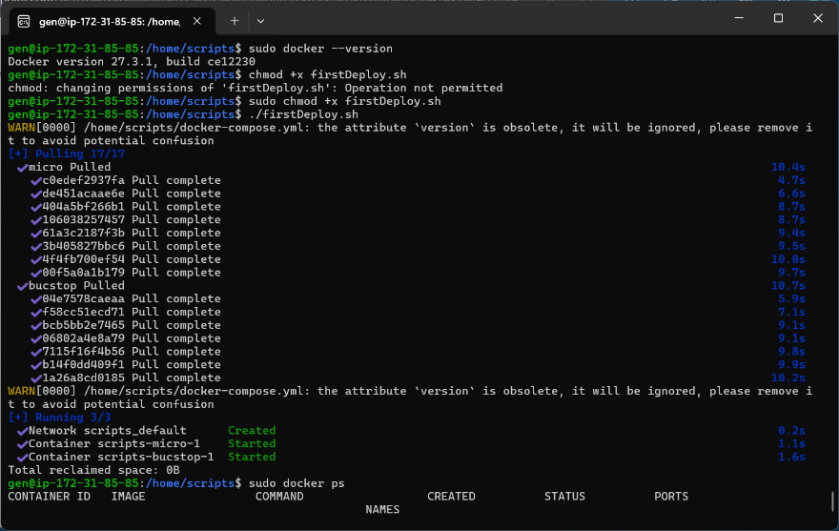

**After the above steps go and open your web browser and type in http//your-ec2-public-ip you can find your-ec2-public-ip on your AWS instance just copy the address under the Public IPv4.**